PROJECT DEVELOPMENT PHASE 3
ServiceNow Environment & Data Setup
Script-Controlled ACL – Restrict Record Access Based on Field Value
Project Details | Values
Date | 30 September 2026
Team ID | SWTID-2026-8983
Project Name | Script-Controlled ACL – Restrict Record Access Based on Field Value
Phase | Phase 3 – ServiceNow Environment & Data Setup
Maximum Marks | 5 Marks

Team Role | Team Member
Team Leader | NITHYA SREE S
Team Member | RAMASRI D
Team Member | PRATHISHA S
Team Member | MEGALA M
Team Member | MANJARI T

1. Objective
Prepare the development instance, sample records, roles, and test accounts needed for safe ACL implementation.

2. Phase Workflow
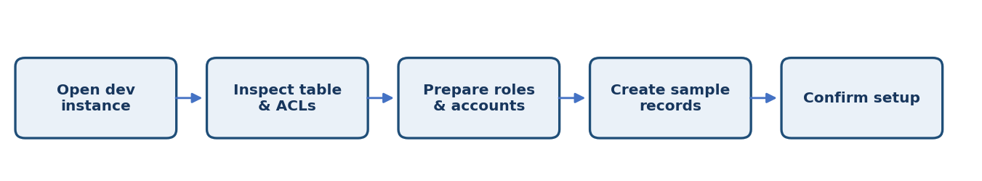

3. Activities / Scope
- Confirm access to the correct development instance.
- Check table and field names, dictionary settings, and existing ACLs.
- Create or verify the required roles and test accounts.
- Prepare sample records for each field value.
- Record baseline behavior before making changes.

4. Sprint Backlog & Estimation
Sprint | Story ID | Requirement | User Story / Task | Story Points | Priority | Team Members
Sprint 3 | US-301 | Inspect existing security | Review ACLs, roles, and table configuration. | 2 | Medium | Project Team
Sprint 3 | US-302 | Prepare roles and users | Set up approved roles and test accounts. | 2 | Medium | Project Team
Sprint 3 | US-303 | Prepare sample data | Create representative records for each access value. | 2 | Medium | Project Team

Total Estimated Story Points: 6

5. Testing / Review Template
Test Case ID | Scenario / Steps | Expected Result | Actual Result | Status
TC-01 | Sign in with each test account and capture baseline access behavior before the new ACL is enabled. | Expected behavior matches approved requirement. | ________________ | Pass / Fail
TC-02 | Record observations, issues, and evidence for this phase. | No unresolved blocker before phase sign-off. | ________________ | Pass / Fail
TC-03 | Review phase deliverables with the responsible team member. | Deliverables reviewed and approved. | ________________ | Pass / Fail

6. Deliverables
- Environment readiness checklist
- Test users and role setup
- Sample test records
- Baseline notes

7. Team Review & Sign-off
Review Item | Details
Prepared by | Megala M / Project Team
Reviewed by | ____________________________
Approval / Date | ____________________________
Remarks | ________________________________________________

